13.BPO MANAGEMENT SYSTEM

ACTIVITY DIAGRAM

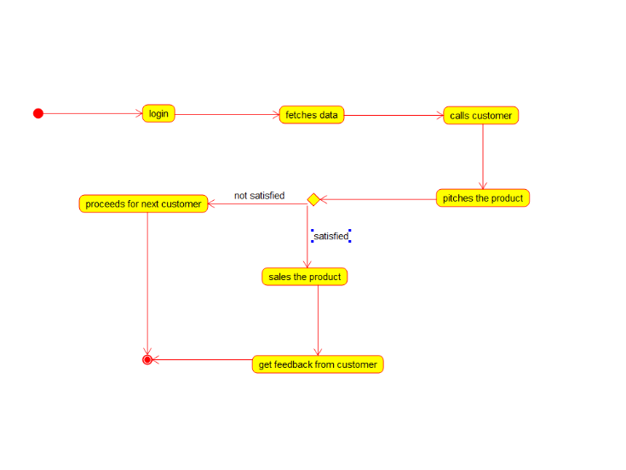

USECASE DIAGRAM

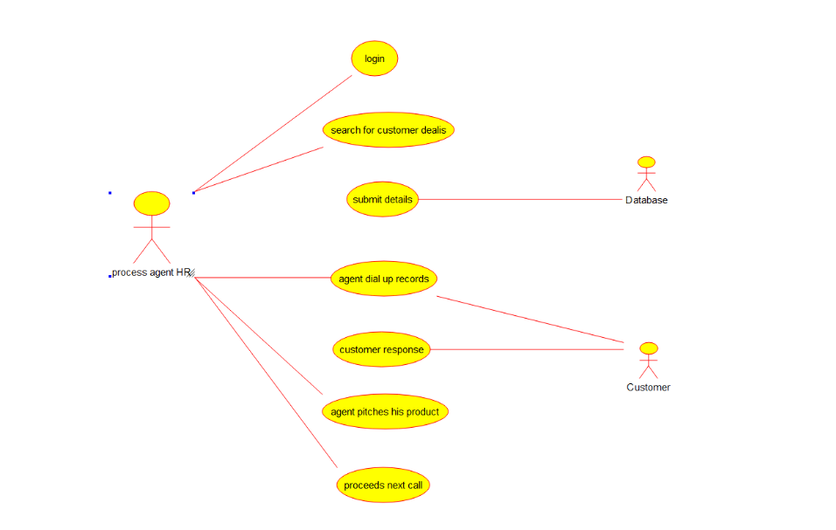

DEPLOYMENT DIAGRAM

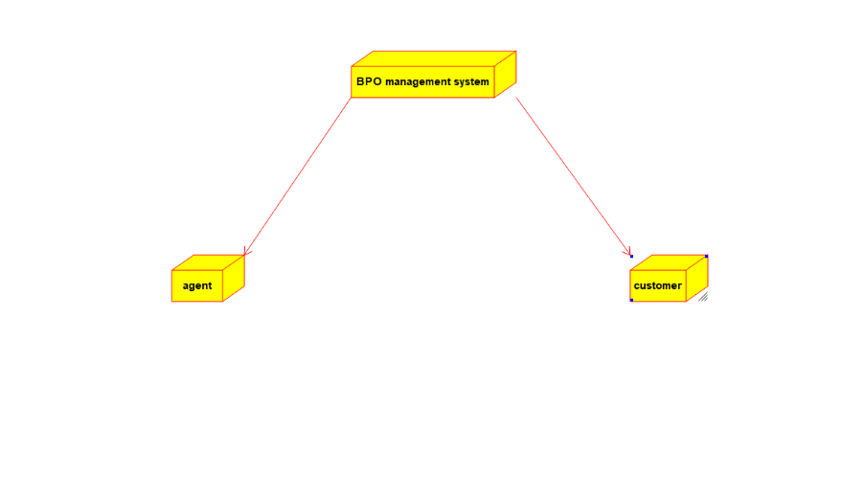

COMPONENT DIAGRAM

